Facts and figures | Belgium

Fresh fruit
- In the 2021-2022 season, Belgium produced 249,742 tonnes of apples, a sharp increase compared to the last few years. 2021 was an exceptionally good year for Belgian apple producers. Around 355,682 tonnes of pears were produced in the 2021-2022 season, slightly less than the season before, but the quality of the pears was good.
- The production of strawberries in 2021 came to around 50,600 tonnes, an increase of 17% compared to 2020.

- In 2021, the export of apples (133,719 tonnes) fell, especially due to a decrease in export within Europe. This is perhaps due (in part) to the large European stocks of apples that were on the market at the time and disrupted trade. Belgium can once again achieve good export volumes in 2022, and for the first 9 months has already achieved 48% more exports than over the same period last year. This applies for both within Europe and on the markets outside the EU.
Belgium’s neighbouring countries remain the main export destinations for Belgian potatoes. Germany represents a share of 29%, making it the second export destination after the Netherlands. France completes the top 3.

Source: Eurostat & VLAM
- Pears are exported to a wide range of different countries. In 2021 the turnover was characterised by good volumes (358,521 tonnes), that unfortunately dropped slightly over the first 9 months of 2022. However, a number of noteworthy, positive trends remain. Estonia has become a very important market for Belgian pears over the past few years and now one of the top 3 destinations, after the Netherlands and France. However Germany (where Belgium has been conducting a campaign for Conference pears for years), Spain, Poland and Italy are buying more and more pears from Belgium too. Export volumes are also increasing on a number of markets that are further away: in China, Brazil, India and recently also Vietnam, the demand for Belgian pears is on the rise.

Source: Eurostat & VLAM

- Belgian strawberries are primarily exported to neighbouring countries. The Netherlands, France and Germany are the main markets, together their share is around 70%. The United Kingdom and Scandinavia are also very important markets for Belgian strawberry exports. In 2021, the total Belgian export of strawberries amounted to over 170 million euros or about 38,500 tonnes.

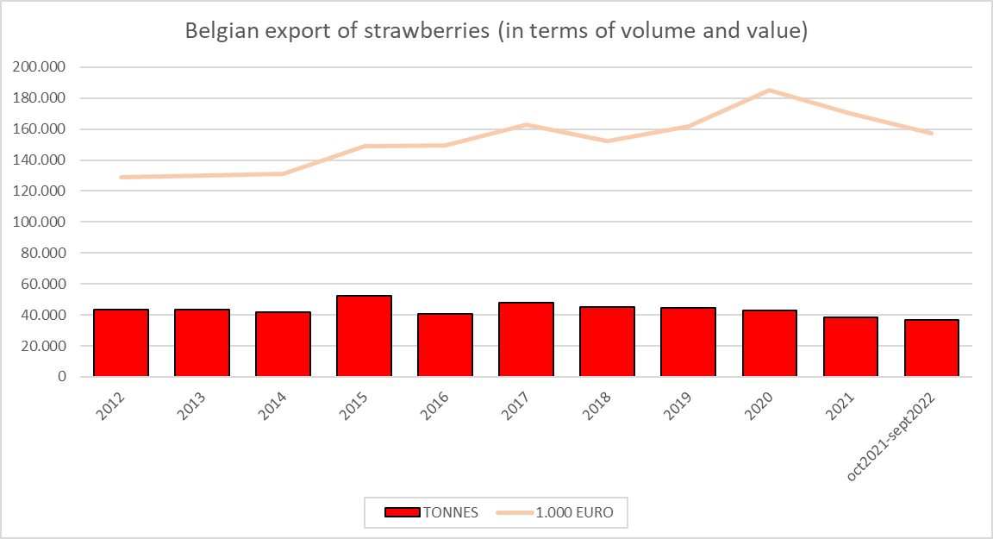
Source: Eurostat & VLAM

Fresh vegetables
- In 2021, around 860,000 tonnes of Belgian vegetables destined for the fresh market were produced.
Tomatoes (over 282,000 tonnes) are the absolute number one. Leeks (127,050 tonnes), carrots (99,750 tonnes), cucumbers (33,000 tonnes), Belgian endives (32,640 tonnes), white cabbage (27,600 tonnes), bell peppers (27,250 tonnes) and lettuces (25,925) are the other cornerstones of Belgian vegetable production.
- In 2021, the Belgian export of fresh vegetables fell in terms of volume (-8%), however the export value did rise (6%). In concrete terms this means that the volume exported in 2021 came to 888,000 tonnes, which came to an export value of 848 million euros. For the first 9 months of 2022 we can see a reversal, with an increase in the export volume but a reduction in the export value.
- The neighbouring countries are by far the most important destinations for fresh vegetables: for years the French market has led the way with an export share of 35% for 2021, followed by the Netherlands (28%) and Germany (17%). However, for the first 9 months of 2022, we can see a remarkable increase in exports to the German market, making it the top destination at present.
Belgian exports of vegetables outside the EU-27 remain limited, with a share of 6% that can largely be attributed to the United Kingdom. Furthermore, we can see African countries, Switzerland and the United States appear as markets.

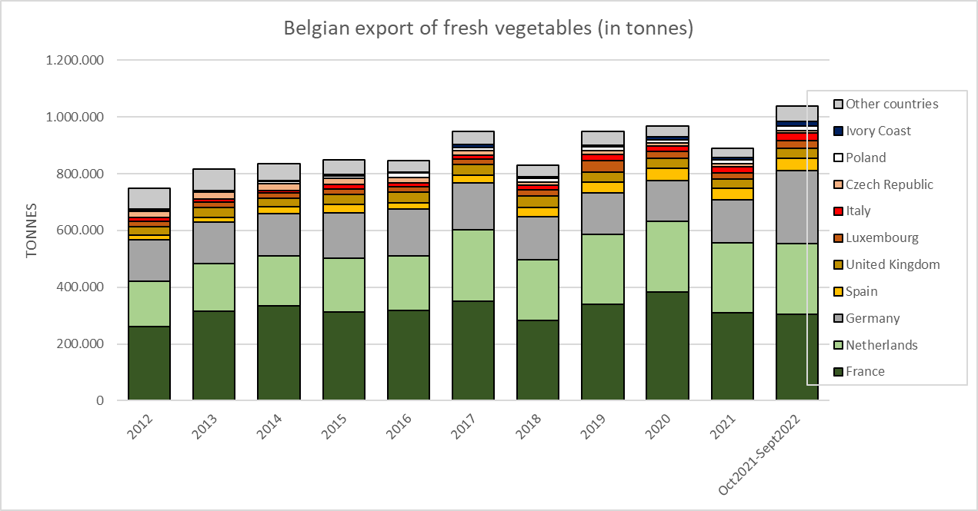

Source: Eurostat & VLAM

Potatoes & potato preparations
- In 2021, the Belgian potato producers produced almost 4 million tonnes of potatoes.
- Belgian exports of potatoes fluctuate, but we can see that in recent years on average the volume is around 950,000 tonnes. The first 9 months of 2022 predict a sharp rise in exports since they are now already 14% higher than for the same period last year. The Netherlands is by far the biggest market, with a share that over the years has continued to increase to 75%. France follows way behind that with a 12% share which has fallen sharply over the years and then Germany which remains stable at 4%.
- Belgian potato preparations continue to confirm their status and are very prized in every corner of the world. Belgium is the global number one exporter of potato preparations. In 2014, exports exceeded 2 million tonnes for the first time and since then have continued to increase. In 2021, exports even achieved a volume of 3 million tonnes and if we look at the first 9 months of 2022, this trend continues. Our neighbouring countries are the main markets, with France (16%), the United Kingdom (13%) and the Netherlands (9%) leading the way. Germany and Spain complete the top 5. Then come Brazil and the United States, that over the years have become far more important markets for Belgian potato preparations. This generally applies for Belgian exports to third countries that over a period of 10 years have more than doubled and currently represent almost half the total Belgian export of potato preparations.

Source: Eurostat & VLAM

Fruit trees
- In general, arboriculture, which includes fruit trees, is on the rise. Increased focus on climate change still offers considerable potential for these products.
- For many years France has been the biggest market for Belgian fruit trees and this neighbouring country has furthermore increased its share of our exports. For the period from October 2021 to end of September 2022, this came to a 50% share of our exports, amounting to a value of over 20 million euros. Italy and Germany follow in second and third place with a 13% and 8% share respectively. The Belgian export of fruit trees is mainly a European affair, but we can also see exports to countries outside the EU-27, such as the United Kingdom, Algeria, Norway and Switzerland to name but a few.
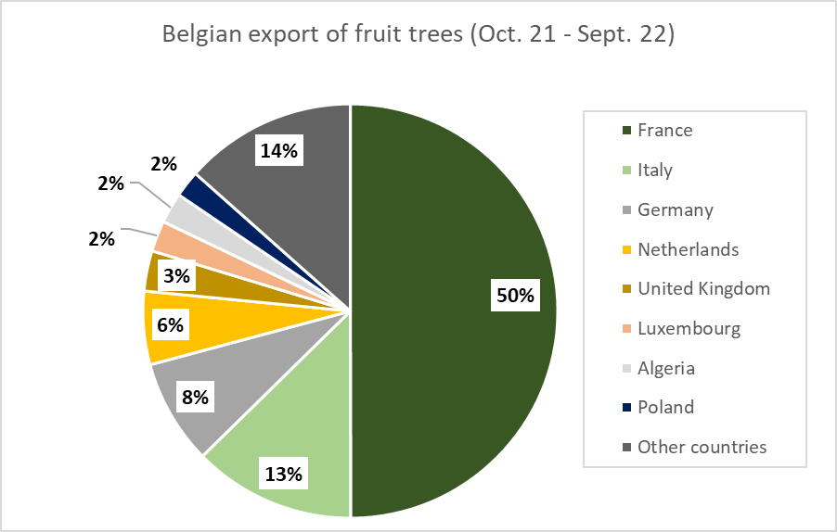
Source: Eurostat & VLAM

